DSA FINAL PROJECT
”Sari-sari Store Inventory System”

Course Code: 201L DSA | Program: BSCpE
Course Title: Data Structure Analysis | Date Performed: November 8, 2025
Section: 2-B | Date Submitted: November 8, 2025
Name:  Luminario, Venice Lou Gabrielle M.  Adoracion, Jerick Dave D.  Calica, Ljay L.  Enverzo, Kyle Andrey D.  Gabuyo, Ivan Love D. | Instructor: Engr. Maria Rizette H. Sayo
- Objectives
This activity is composed of group ideas and suggestions. Here are the following objectives:

- To implement a reliable database system storing and managing users, inventory, and sales records securely and efficiently.

- To make a simple user-interface design

- To add a simple log-in feature

- To implement different data types such as linked- list to our system

2. Discussion
The development of the Sari-sari Store Inventory System began with careful planning and system design. The team first brainstormed ideas, outlined the flow of the program, and decided to use Python as the main programming language due to its versatility and user-friendly nature. The initial phase focused on building the login and signup system, allowing new users to register and existing users to securely log in. Once authenticated, users were directed to a prototype cashier dashboard labeled “Joan’s Store.” This served as the foundation for future system features and provided a clear structure for the user interface.

As development progressed, the team integrated a linked list structure to improve data handling for cart items and sales history, setting the groundwork for efficient transaction tracking. New features were also added to enhance functionality and usability, including a search bar implemented through the search_item() and update_item() functions, which filtered items dynamically using SQL-like queries. Additionally, a real-time date and time display and a quantity input field were added to support transaction tracking and future automation features. The database, managed using MySQL, was initialized with init_db() to ensure that all product details, prices, and stock information were properly stored and retrieved through the system.

.
In the latest stage of development, the system was optimized for better performance and user convenience. Several functional buttons were introduced, allowing users to add items, generate and view receipts, monitor sales, check stock levels, and log in or out securely. All these features operated smoothly under the main App class, which maintained the connection between the interface and database through the continuous loop app.mainloop(). The project underwent rigorous testing to ensure data accuracy, responsiveness, and overall reliability. Ultimately, the team created a functional, easy-to-use inventory and sales management system that streamlined store operations and strengthened their technical and problem-solving skills.

3. Materials and Equipment
Computer: used to make the source code for the Skill-Test Visual Studio Code: used for running the program
Github: used to collaborate and manipulate the program Mouse: used to navigate the Computer
Keyboard: Used to type the source code
4. Output
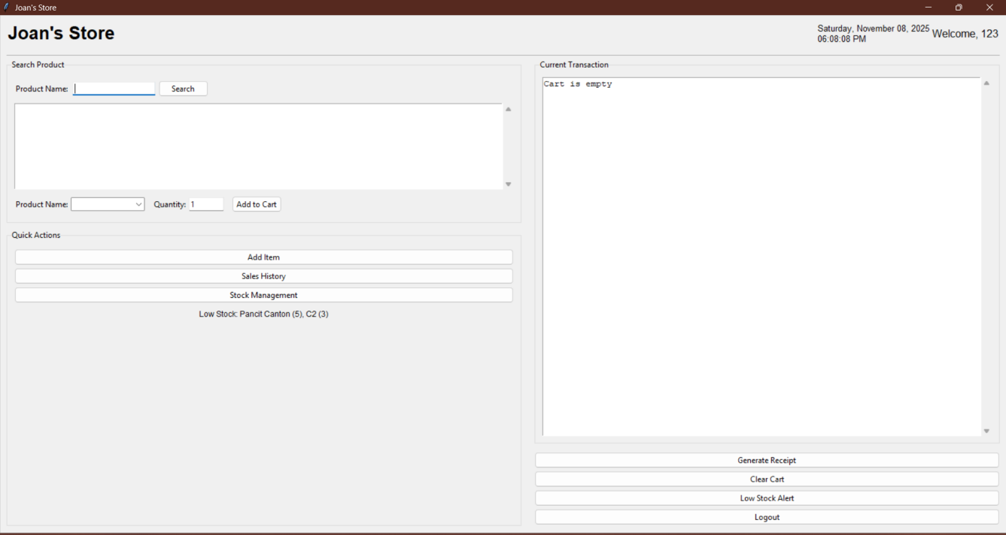
Figure 1: Output

5. Pseudocode
BEGIN

INITIALIZE system
CREATE linked list for products, sales, and cart
LOAD sample products into product linked list

DISPLAY main interface:
SHOW title "Joan’s Store"
SHOW date and time
SHOW sections: Search, Cart, Quick Actions

LOOP while application is running:
IF user searches for product THEN
SEARCH linked list for product
DISPLAY results
IF user adds product to cart THEN
CHECK stock quantity
IF available THEN
ADD product node to cart linked list
ELSE
SHOW "Not enough stock" message

IF user generates receipt THEN
CALCULATE total
DEDUCT stock from products
ADD sale record to sales linked list
DISPLAY receipt window
CLEAR cart

IF user clicks "Add Item" THEN
INPUT product name, price, quantity
ADD new node to product linked list

IF user clicks "Restock" THEN
FIND product node
ADD quantity to existing stock

IF user clicks "Sales History" THEN
DISPLAY all records from sales linked list

IF user clicks "Low Stock Alert" THEN
DISPLAY products with quantity ≤ 10

IF user clicks "Logout" THEN
EXIT loop and close program
END LOOP
END

6. Algorithm
Start Initialize the program. Set Application_Running = TRUE.
While Application_Running = TRUE
- If user clicks "Logout", then
→ Exit loop and close program.

- Else, continue running the program.

c. If user searches for a product, then
→ Search linked list for the product.
→ Display search results.
d.If user adds a product to cart, then
→ Check stock quantity.
→ If stock is sufficient,
→ Add product to cart.
→ Else, show “Not enough stock” message.

e. If user generates a receipt, then
→ Calculate total amount.

f. If user clicks "Add Item", then
→ Input product details.
→ Add new product node to linked list.

g. If user clicks "Restock", then
→ Find product node.
→ Add quantity to stock.
h. If user clicks "Sales History", then
→ Display sales records. i. If user clicks "Low Stock Alert", then
→ Display products with low stock.
End While
Stop program

- Source Code
https://colab.research.google.com/drive/1gqW8H69yiyTPxgnfESQvWiklt7AFGKjH?usp=sharing

- Flowchart
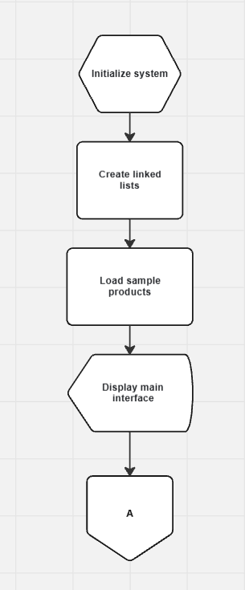
Figure 2.1: Flowchart

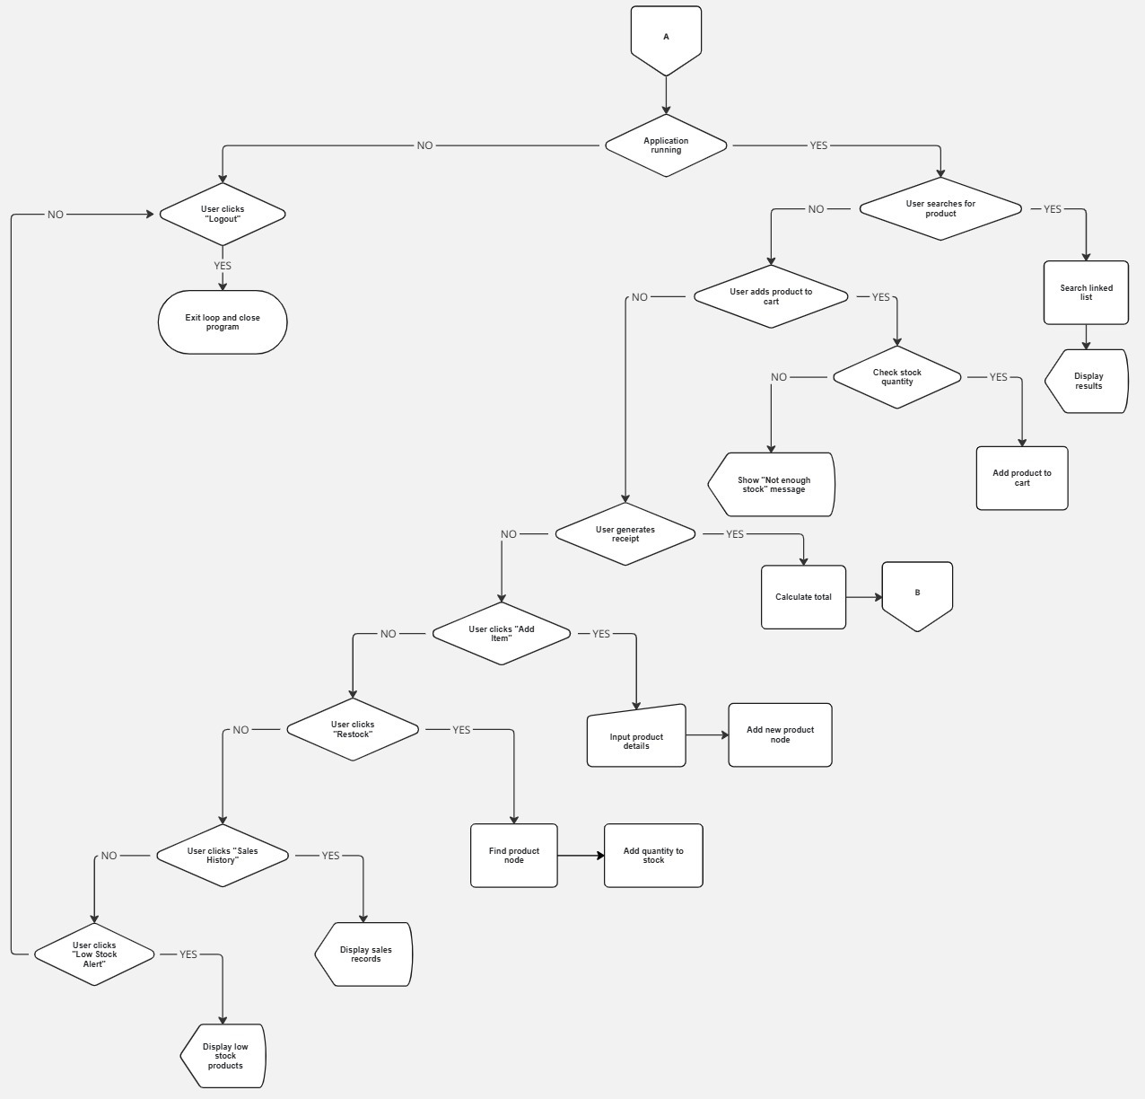
Figure 2.2: Flowchart

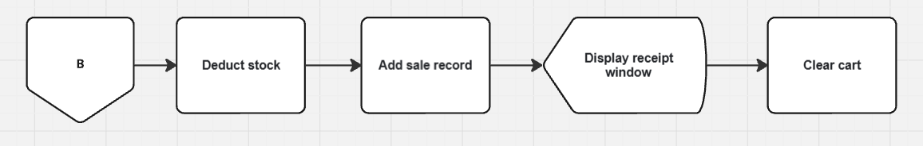
Figure 2.3: Flowchart

9. Conclusion
Throughout the development of our Sari-sari Store Inventory System, our group made significant progress in transforming a simple idea into a functional, user-friendly cashier and inventory management application. Starting from the initial design of a basic interface with a login and signup feature, we gradually expanded the system to include key functionalities such as real-time date display, product search, and essential cashier tools like “Add Item,” “Generate Receipt,” “Sales History,” “Add Stock,” “Edit Price,” and “Low Stock Alerts.” These improvements have streamlined daily store operations, enhanced inventory tracking, and made the system more efficient and responsive to user needs.
Our revisions to the original project from our Database Management System course allowed us to strengthen both the front-end design and the back-end logic. By incorporating Python and linked list data structures, we improved the efficiency of product management and data handling. The updated user interface not only provides smoother navigation but also presents information in a clearer and more accessible way for cashiers and store administrators. Future updates, including the planned Storage Room Module, aim to centralize product flow monitoring and further enhance stock management accuracy.
Overall, this project has been a valuable hands-on experience that strengthened our technical and collaborative skills as computer engineering students. It allowed us to apply classroom knowledge in programming, database management, and user interface design to a real-world problem. Through teamwork and innovation, we created a system that simplifies retail operations and improves user experience, laying the foundation for a scalable and professional-grade point-of-sale solution that can continue to grow and adapt to future needs.

- References
[1] S. A. Asaduzzaman, A. S. Haque, and R. Hasan, "Design and implementation of a computerized point of sale (POS) system," 2019 International Conference on Electrical, Computer and Communication Engineering (ECCE), Cox’sBazar, Bangladesh, pp. 1-5, Feb. 2019. doi: 10.1109/ECACE.2019.8679363

[2] D. Kim and H. Lee, "Development of Point-of-Sale (POS) System for Small-Scale Retailers," International Journal of Computer Applications, vol. 182, no. 2, pp. 1–5, Jul. 2018. doi: 10.5120/ijca2018917392

[3] M. A. Hossain, M. R. Kabir, and A. Islam, "Inventory Management System with Automatic Low Stock Alert," International Journal of Advanced Computer Science and Applications (IJACSA), vol. 10, no. 7, pp. 150–157, 2019. doi: 10.14569/IJACSA.2019.0100720

[4] A. Jain, R. Patel, and S. Bhardwaj, "Enhancing Retail Operations with Improved User Interface Design in POS Systems," 2021 6th International Conference on Communication and Electronics Systems (ICCES), Coimbatore, India, pp. 1234–1239, Jul. 2021. doi: 10.1109/ICCES51350.2021.9489267

[5] K. Singh and P. Sharma, "Application of database management and GUI design in sales tracking systems," International Journal of Innovative Research in Computer and Communication Engineering (IJIRCCE), vol. 7, no. 4, pp. 14567–14573, Apr. 2019. doi: 10.15680/IJIRCCE.2019.0704035

